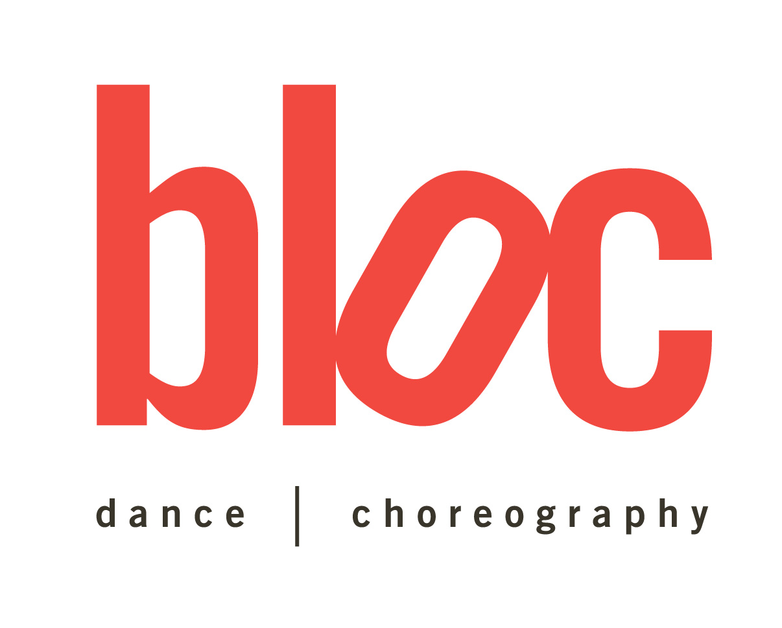

**bloc, NYC**

630 9th Ave

7th fl

New York, NY 10036

PHONE: 212-924-6200

**Tanesha “Ksyn” Cason**

**(Kay-sin)**

www.MissKsyn.com

**(SAG, AFTRA)**

Hair: Black Height: 5’7”

Eyes: Brown Age: 27- 41

**Film**

In the Heights Dancer Dir: Jon M. Chu/ Chor: Christopher Scott

Detective Chinatown 2 Cheerleader/Dancer Dir: Sicheng Chen/ Chor: Tanisha Scott

Fighting Shevonne Dubai Dir: Dito Montiel

Brooklyn’s Finest Sexy Money Girl Dir: Antoine Fuqua

Your Nobody Til Somebody Kills You Studio Guest Dir: Spike Lee

Sex and the City 2 Extra Dir: Michael Patrick King

**Documentary**

Beyoncé: Life is but a Dream (documentary) Principal Dancer Dir: Beyoncé, Ed Burke, lan Y. Benata

**Television**

Dick Clark’s Rocking New Years Eve 2024 LL Cool J Dancer Dir: Glenn Weiss/ Chor: Hi Hat

Live w/ Kelly and Ryan Static and Ben El ft. Pit Bull Dancer Chor: Olivia Cipolla/Christina Pagan

Good Morning America Static and Ben El ft. Pit Bull Dancer Chor: Olivia Cipolla/Christina Pagan

Black is King Dancer Chor: Jaquel Knight

Lip Sync Battle season 5 Dancer (1 episode) Chor: Danielle Flora/ Adar W./ Anthony Kin

Lip Sync Battle Live: Michael Jackson Celebration Dancer Dir: T.J. Shanks/ Chor: Squared Division/Danielle F.

Lip Sync Battle Live : A BET Awards Special Principle Dancer Chor: Danielle Flora/ Adar W./ Anthony Kin

Lip Sync Battle season 4 Core Dancer Chor: Danielle Flora/ Adar W./ Anthony Kin

Lip Sync Battle season 3 Core Dancer Chor: Danielle Flora/ Adar Wellington

Lip Sync Battle Live Principle Dancer Dir: Beth Mcarthy – Miller/ Chor: Danielle Flora

The Tonight Show w/ Jimmy Fallon Lilly Allen Dancer

Sex, Drugs and Rock & Roll (s:1. Ep. 8) Dancer Dir: Matt Whitecross/Chor: Tanisha Scott

Vinyl Dancer Dir: Martin Scorsese/Chor: Aakamon Jones

Black Girls Rock 2016 Brandy Dancer Chor: Frank Gatson Jr./Luam

Black Girls Rock 2016 Tracey Ellis Ross/Jazmine Sullivan Chor: Luam/Jermel

Superbowl 50 Halftime Show 2016 Beyoncé Dancer Chor: Chris Grant/Jaquel K.

The Tonight Show with Jimmy Fallon R Kelly Dancer Chor: Frank Gatson Jr.

Lemonade Beyoncé Principle Dancer Dir: Beyoncé/ Khalil Joseph

Lip Sync Battle Season 2 Core Dancer Chor: Danielle Flora/Nicole S

Good Morning America Demi Lovato (extra)

Lip Sync Battle Season 1 Dancer Dir: Beth Mcarthy – Miller/ Chor: Danielle Flora

HBO presents On the Run: Beyoncé and Jay Z Dancer Dir: Jonas Akerlund

Video Music Awards 2014 Beyoncé Dancer Chor: Chris Grant/ Dana F.

America’s Got Talent Tone the Chief Rocker Dancer Chor: Luam

Pepsi presents The Superbowl Halftime Show 2013 Principle Beyoncé Dancer Chor: Frank Gatson Jr.

MTV World Stage: Sean Paul Dancer Chor: Tanisha Scott

Waratte Litomo (Japan) Sean Paul Dancer Chor: Tanisha Scott

MTV Japan Presents: Sean Paul Live Dancer Chor: Tanisha Scott

Oprah’s Surprise Spectacular Beyoncé Principle Dancer Chor: Frank Gatson Jr.

Billboard Awards 2011 Beyoncé Principle Dancer Chor: Frank Gatson Jr.

Comedy Central Comedy Awards 2011 Jon Cryer Dancer Chor: Danielle Flora

Rip the Runway 2011 Carnival Dancer Chor: Adrian Wilshire

Saturday Night Live w/ Jim Carey Worst of Soul Train Chor: Danielle Flora

The Tonight Show w/ Jimmy Fallon – NERD Dancer

106 & Park – NERD Dancer

The Tonight Show w/ Jay Leno – NERD Dancer

The Tonight Show w/ David Letterman - NERD Dancer

Video Music Awards 2010 – NERD & Ciara Dancer Chor: Jamaica Craft

Deejay Tv (Milan) NERD Dancer

MTV London NERD Dancer

World Music Awards NERD Dancer

Jimmy Kimmel Live – NERD Dancer

BET Awards Pre Show 2010 – NERD Dancer

How to make it in America (Season 2/ep.2) Stace/Stripper Dir: Julian Farlino

BET Awards Pre Show 2009 Jeremih Dancer Chor: Tanisha Scott

30 Rock (ep.521) Stripper #1 Dir: Don Scardino

Good Morning America Ciara Dancer Chor: Jamaica Craft

Regis & Kelly Ciara Dancer Chor: Jamaica Craft

MTV Australian Music Awards EVE dancer Chor: Tanisha Scott

NBC Today Show w/ Anne Curry Sean “Puffy” Combs Dancer

106 & Park Sean Kingston Dancer Chor: Sho Tyme

**Music Videos**

Drake – In My Feelings Dancer Dir: Karena Evans/ Chor: Tanisha Scott

Beyoncé – Formation Dancer Dir. Melina Matsoukas/ Chor: Chris Grant

Beyoncé – Grown Woman Dancer Dir: Jake Nava/ Chor: Chris Grant/ Les Twins

Beyoncé – Blow Dancer Dir: Hype Williams/ Chor: Beyoncé/Chris Grant

Beyoncé – XO Dancer Dir: Terry Richardson/ Chor: Beyoncé

Sean Paul - Dream Girl Dancer Chor: Tanisha Scott

Busta Rhymes ft. Chris Brown - Why Stop Now Dancer Dir: Hype Williams

Mary J Blige “Mr. Wrong” Dancer Dir: Diane Martel/ Chor: Hi Hat

50 Cent ft Yayo “I Just Wanna” Principal Dir: Jackson Smith

Phiten Presents: Pac Div “Still Flexin” Model

Cav Bernah “O.J.” Lead Dir: Cav Bernah/ Ksyn Cason

Bliz Cardai “One of a Kind” Trumpet player ` Dir: Marlin Smith

Elle Varner ft. J Cole “Only Wanna Give it to You” Elle’s Friend (Principal) Dir: Alex Germanotta

Sha Stimuli “Wake up & Go” Lead Dir: RH Bless

Esso “Big Bed” Lead Dir: Puma

Spragga Benz ft. Sean Paul “Call Upon Jah Jah” Dancer

Bob Sinclar ft. Sean Paul “Tik Tok” Dancer Dir: Hype Williams

NERD “Hot and Fun” Dancer Dir: Jonas Åkerlund

Usher ft. Nicki Minaj “Lil Freak” Dancer Dir: Taj/ Chor: Aakamon “Aj” Jones

DJ Envy ft. Red Café “Dolla Bill” Model Dir: Scenario

Sean Paul “Now that I Got Your Love” Dancer Dir: Little X/ Chor: Tanisha Scott

Deon Young “Drank In My Cup” (Kirko Bangz Cover) Lead

Danny Fernandes ft Juelz Santana “Curious” Dancer

Jeremih “Make up to Break up” Dancer Dir: Taj/ Chor: Tanishsa Scott

Ciara ft Justin Timberlake “Love, Sex & Magic” Dancer Dir: Diane Martel

Serani “No Games” Dancer Dir: Max Nichols

Jay Z “Roc Boyz” Model Dir: Chris Robinson

Keyshia Cole ft. Missy Elliot & Lil Kim “Let it go” Model Dir: Benny Boom

Christian Alexanda ft. Ja Rule “Too Fine” Dancer Dir: JCVisuals

Razah “Rain” Model

Camp Lo “Lumdi” Dancer Dir: Uti

G Unit “I’m a Rider” Dancer Dir: Jesse Tererro

Young Berg ft. Jim Jones & Rich Boy “Hey Sexy Lady Remix” Featured Model Dir: Dale “Rage” Resteghini

50 Cent “I Get Money” Featured Model Dir: Broadway

Kat de Luna “Whine Up” Featured Model Dir: Gil Green

Oxxygen ft. Ksyn “G Spot” Lead Dir: Vladimir Maslakov

King Wawa “All I ever Dream” Lead Dir: Lamont Liquid

Jinx da Juvy “Strong Enough” Featured Model Dir: Lamont Liquid & Phil Gates

**Dance (Live)**

Rolling Loud Festival 2021 50 Cent Dancer Chor: Hi Hat

Power: The Final Chapter Premiere Event 50 Cent/Case/Snoop Dog Dancer Chor: Hi Hat

V Files Fashion Show Brooke Candy ft. Ericka Jayne Chor: Mikey Minden

Assassination Vacation Tour 2019 Dance Captain Chor: Tanisha Scott

Aubrey and the Three Migos Tour 2018 Dance Captain Chor: Tanisha Scott

Empire Pepsi Commercial Launch Jussie Smollett Dancer Chor: Frank Gatson Jr.

Empire Premiere Event (Carnegie Hall) Jussie Smollett Dancer Chor: Frank Gatson Jr.

Global Citizens Festival Beyoncé Dancer Chor: Chris Grant/Dana F.

Made in America 2015 Beyoncé Dancer Chor: Chris Grant/Dana F.

Beyoncé and Jay Z, On the Run Tour 2014 Dancer Chor: Chris Grant/Dana F.

VH1 Superbowl 2014 Blitz Concert Series TLC Dancer Chor: Jamaica Craft

Alexandra Burke Promo Show (NYC) Dancer Chor: Jaquel Knight

Essence Festival Beyoncé Dancer Chor: Frank Gatson Jr.

Chime for Change Beyoncé Dancer Chor: Frank Gatson Jr

Rock in Rio Beyoncé Dancer Chor: Frank Gatson Jr.

V Festival Beyoncé Dancer Chor: Frank Gatson Jr.

Made In America Festival Beyoncé Dancer Chor: Frank Gatson Jr.

Beyoncé, The Mrs. Carter Show World Tour 2013/14 Dancer Chor: Frank Gatson Jr.

Sean Paul Tomahawk Technique Tour Dancer Chor: Tanisha Scott

Beyoncé Live at Revel Dancer Chor: Frank Gatson Jr.

Rockcorps Sean Paul Dancer Chor: Tanisha Scott

Sean Paul France Tour Dancer Chor: Tanisha Scott

Red Bull Secret Tour (Europe) Sean Paul Dancer Chor: Tanisha Scott

Coca Cola La Brigade du Bonheur’s Block Party Sean Paul Dancer Chor: Tanisha Scott

Nottinghill Carnival Festival (London) Sean Paul Dancer Chor: Tanisha Scott

Pacific Grooves Festival Sean Paul Dancer Chor: Tanisha Scott

Arona Summer Festival Sean Paul Dancer Chor: Tanisha Scott

Summer Jam (Germany) Sean Paul Dancer Chor: Tanisha Scott

Red Bull Festival Sean Paul Dancer Chor: Tanisha Scott

Colmar Festival Sean Paul Dancer Chor: Tanisha Scott

A Rock Night Festival Sean Paul Dancer Chor: Tanisha Scott

Chiemsee Reggae Festival Sean Paul Dancer Chor: Tanisha Scott

Jingle Ball 2011 Sean Paul Dancer Chor: Tanisha Scott

RockCorps NERD Dancer

The Fillmore at Irving Plaza NERD Dancer

Coke Live Festival NERD Dancer

Fashions Night Out (NYC) NERD Dancer

NYC Fashion Week 2010 NERD Dancer

Art Basel: Paper Magazine NERD Dancer

Paleo Festival NERD Dancer

Putte Parken Festival NERD Dancer

Tour de France Party NERD Dancer

Great Lake Festival NERD Dancer

Heineken Jammin Festival NERD Dancer

Chocolate City Tour w/ Janelle Monáe & Erykah Badu NERD Dancer

Escape to Plastic Beach Tour US/Canada – NERD Dancer

Tony Hawk and Friends – NERD NERD Dancer

E3, Los Angeles – NERD NERD Dancer

Matiesse Promo (Boston) Dancer Chor: Frank Gatson Jr./ Chris Grant

Sean Paul Imperial Blaze Promo Tour Sean Paul Dancer Chor: Tanisha Scott

All About You Promo Tour Jeremih Dancer Chor: Tanisha Scott

America’s Most Wanted Tour Jeremih Dancer Chor: Tanisha Scott

Dutty Rock Promo Tour – Sean Paul Sean Paul Dancer Chor: Tanisha Scott

Fantasy Ride Promo Tour Ciara Dancer Chor: Jamaica Craft

Backstreet Boys Unbreakable Tour – Donnie Klang Dancer Chor: Alyssa Vacco

The Rolling stone Promo Tour – Donnie Klang Dancer Chor: Alyssa Vacco

Alicia Keys & Friends AIDS Benefit Concert EVE Dancer Chor: Tanisha Scott

Ashanti Promo Tour Ashanti Dancer Chor: Brice Vick

Joe Thomas European Valentine’s Day Tour Joe Thomas Dancer Chor: Tik Tok

Joe Thomas Promo Tour Joe Thomas Dancer Chor: Tik Tok

**Assistant/Contributing Choreographer/Movement Coach/Runway Coach**

Dubai World Festival 2021 Alicia Keys Assistant/Contributing Choreographer

Live w/ Kelly and Ryan Static and Ben El ft. Pit Bull Contributing Choreographer

Good Morning America Static and Ben El ft. Pit Bull Contributing Choreographer

Assassination Vacation 2019 Drake Assistant Choreographer

Aubrey & the Three Migos Drake Assistant Choreographer

Gabi Wilson (Formerly known as HER) Movement Coach

Nya Movement Coach

TCM Management Runway Coach

Lip Sync Battle (Seasons 1-4) Contributing Choreographer

The Talk OMI Assistant Choreographer

The Dollhouse (Urban Burlesque Show) Contributing Choreographer

**Burlesque**

The Dollhouse (Urban Burlesque Show) Soloist 2013

Siren Assassins (LA) Kaori Couture 2010

Siren Assassins (NYC) Kaori Couture 2009/2010

**Commercials**

NY Presbyterian Hospital Pedestrian/walking 2022

Lip Sync Battle 3 promo Dancer 2016

Facebook 360 ad Featured Pedestrian 2016

Revol Wireless (Ohio) Lead 2012

C & A Clothing (Brazil) Beyoncé Dancer 2010

ESPN Xmas NBA Commercial with Mariah Carey Dancer 2010

Lucille Roberts Dancer 2008, 2009

**Voice over**

Facebook 360 ad commercial Featured Pedestrian 2016

**Modeling**

K Nubian Collection Brand Ambassador 2020 - Present

Cartier In house training model 2021

Caviar Diamond Nails Brand Ambassador/ Collaborator 2020

Good Vibes Collection Brand Ambassador/ Collaborator 2022/2023

Illa Sparks Accessories Brand Ambassador/ Model 2017/2018

It’s A Wig! Brand Ambassador 2014

U by Kotex Tampons Model 2014

Soca Gold Cover Model 2012

Ilovebeeing.com Model 2012

My Fair Wedding Model Advertisement 2012

Dr. Jays.com/ Spring Trends Model Spring 2011

Red Gold Trading Company.com Model Spring 2009

NTice Clothing.com Model Spring 2009

Harlem Fashion Week Runway Model 2008/2009

**Print**

Table of Contents Model Crop Over Magazine (Barbados)

Ksyn: It Cyan be ova Interviewee, pgs. 4 & 5 Easy Magazine (Barbados)

Meet Ksyn Cason Advertorial/ pg. 95 Hype Hair Magazine Dec. 2014

Essence Festival Recap Featured Beyoncé Dancer Essence Magazine 2013

Beyonce’s Backups Cover/Interviewee pgs. 38 -44 Dance Spirit Magazine 2013

Get Fierce & Fabulous with Walmart Model, pgs. 82 – 83 Hype Hair Magazine 2010

The Women of King Interviewee, pgs. 82 – 91 King Magazine Summer 2010

Chasin Ksyn Interviewee, pg 128 Dance Spirit Magazine 2009

Essence Magazine Page 145 Essence Magazine 2009

Thug Lovin’ Book Cover Model Wahida Clark

Straight Stuntin’ Magazine Featured Model Straight Stuntin Magazine

Urban Curves Magazine Model, pgs. 24 & 25 Urban Curves Magazine 2009

Assets Model, pg. 57 As-Is Magazine Issue 4

Ksyn (featured) Model, pages 22-25 IB Concepts magazine Cover Model

Long and Strong/ Step by Step Hair Model, pgs. 55, 60 Hype Hair Magazine 2009

Ebony Magazine Stock Photography Model Ebony Magazine 2009

Break Out Model, pg. 31 King Magazine 2008

Ksyn (featured) Model, pgs. 50 & 51 Liquid Magazine 2008

Lingerie Preview Model, pg. 21 Fire Magazine 2007/08

Fresh off the Hanger Model, pg. 61 The Source Magazine 2008

It’s Your Birthday Model, pgs. 197, 210 – 211 XXL Magazine 2008

Smooth Girl Interviewee, pgs. 82 – 87 Smooth Magazine 2007

Love Your Body Model Elle Girl Magazine 2006

**Tradeshows**

The Project Convention, NYC Model Toxic Fish UK Clothing

The Magic Convention, Las Vegas Model Nostic Clothing

**Industrials**

Fox Upfronts NFL Sunday 24k dancer Chor: Anthony Kin & George Jones Jr.

Fox Upfronts Empire (Jussie Smollett dancer) Chor: Frank D. Gatson Jr.

**Radio**

Lip Service w/ Angela Yee – Jamie Foxx Guest

Lip Service w/ Angela Yee – Q Tip Guest

Lip Service w/ Angela Yee – Lady Saw Guest

Maxim Radio Guest

Thermal Sound Waves w/ Kev Lawrence & C Truth Guest

**Hosting**

The Dollhouse: Urban Burlesque Preview Host 2019

Chictini Host

**Go Go/ Club**

Meg The Stallion “Plan B” Party Dancer

Cardi B. & Playboy Met Gala Afterparty Dancer

NERD Listening Party Dancer

Beyonce & Lorraine Schwartz Jewelry Collaboration Dancer

Club Pacha Dancer

FEDS Magazine release party Dancer

Le Souk Dancer

**Promotions**

Tower Heist Movie Launch Entrance Dancer

UWF (underground rap battle) Ring Girl

Rip the Runway Fashion Police

Proline Auto Shop Model

Atari Model

Kool Cigarettes Model

Hypnotic Liquor Model

Apple Bottoms Co. Model

Alize Liquor Model

**Education**

August 2001– May 2005 Franklin Pierce College Rindge, NH

* Bachelor of Science in Arts Management with a concentration in Dance

**Awards and Certificates**

* The Outstanding Achievement in Dance Award from Franklin Pierce college for outstanding ability and excellence in the area of Dance. [2004]
* The Dennise Messier Memorial Scholarship Award in recognition of talent and leadership in dance and a strong commitment to community service from Franklin Pierce College. [2004]
* Two consecutive full scholarship Awards to the American Dance Summer Festival hosted by Duke University in Durham, NC. [2003/2004]

**Special Skills**

Cheerleading, Step/Stomp, Hip Hop Dance, Modern Dance, African dance, Dance Hall, Double Dutch, Aerobics, Heels